EXPERIMENT 01
FOOTPRINTING ON TARGET NETWORK USING SEARCH ENGINES, WEB SERVICES, AND SOCIAL NETWORKING SITES

1. AIM
To collect basic information about a target organization or network using search engines, public web services, and social networking sites, without directly interacting with the target's live systems.

2. THEORY
Footprinting (reconnaissance) is the fundamental first step of ethical hacking. It involves systematically gathering publicly accessible information about a target organization before any technical testing.
Passive Footprinting focuses entirely on OSINT (Open Source Intelligence). It does not send direct probes or network traffic to the target's servers, ensuring the activity remains completely undetected and logged only by third-party services (e.g., search engines, domain registries).
Key OSINT information vectors include:
• Employee lists, job titles, and internal email address structures.
• Web technology stacks, server software, and cloud infrastructure.
• Physical office locations, contact phone numbers, and operational details.
• Exposed network entry points, internet-connected devices, and public subdomains.

3. TOOLS REQUIRED
- Firefox Web Browser (Kali Linux)
- Google Search (Advanced Operators / Dorks)
- Shodan Engine (https://www.shodan.io)
- theHarvester (Kali Built-in CLI Tool)
- Social Media Platforms (LinkedIn, Twitter/X, Facebook)

4. PROCEDURE & COMMANDS
Step 1: Execute Google Dorking Queries
Open Firefox and enter advanced search operators to uncover indexed sensitive files, directory listings, and portal pages for the target domain:
site:targetcompany.com
site:targetcompany.com filetype:pdf
site:targetcompany.com intitle:"index of"
site:targetcompany.com inurl:admin
"targetcompany.com" intext:"confidential"

Step 2: Run theHarvester for Subdomain & Email Gathering
Open a terminal on Kali Linux and query public engines for emails, subdomains, and host IP addresses:
theHarvester -d targetcompany.com -b google
theHarvester -d targetcompany.com -b all

Step 3: Search Shodan for Internet-Exposed Infrastructure
Navigate to Shodan and enter the target organization filter to locate exposed routers, web servers, and open ports:
org:"Target Company Name"

Step 4: Conduct Social Media Reconnaissance
Inspect LinkedIn employee profiles for specific technology stacks (e.g., 'Cisco ASA Administrator', 'AWS Solutions Architect'), and review posted photos for exposed security badges or internal network diagrams.
Step 5: Consolidate OSINT Findings
Compile all gathered intelligence into an OSINT target profile matrix.

5. LAB OBSERVATIONS & OUTPUT SCREENSHOTS
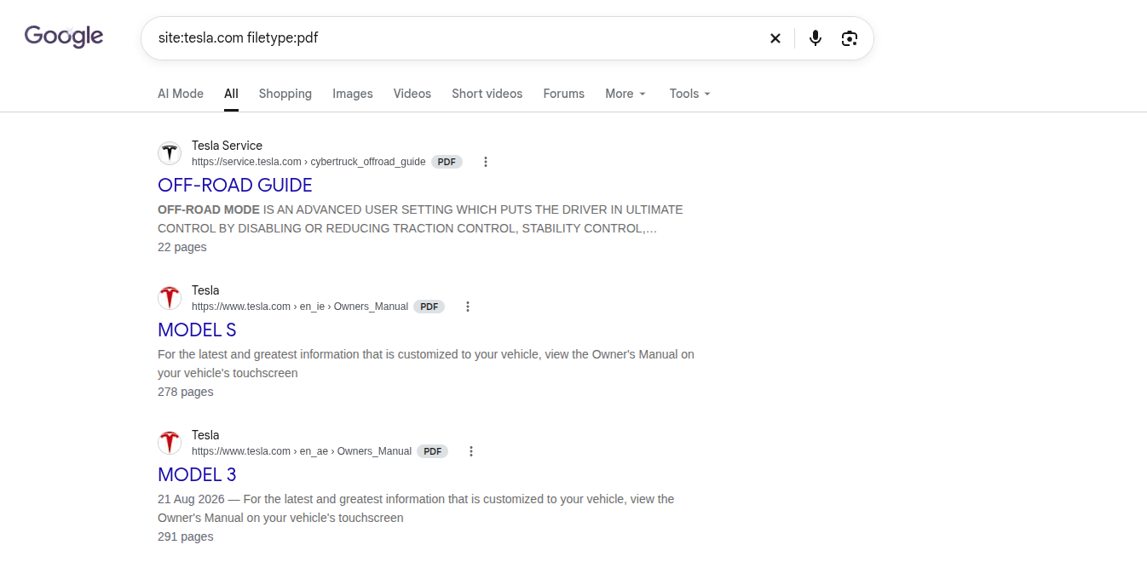

6. EXPECTED OUTPUT RESULT
A comprehensive OSINT reconnaissance report detailing verified employee email formats, discovered subdomains, public IP addresses, exposed server infrastructure on Shodan, and technology stacks identified via social engineering sources.

7. VIVA VOICE QUESTIONS & ANSWERS
S.NO & VIVA QUESTION | TECHNICAL ANSWER
Q1. What is the difference between passive and active footprinting? | Passive footprinting gathers target information without sending direct traffic or probes to the target's systems (e.g., using search engines and public databases). Active footprinting directly interacts with the target's devices (e.g., port scanning), generating log entries on the target network.
Q2. Why is Google Dorking considered a footprinting technique and not hacking? | Google Dorking queries data that has already been crawled and publicly indexed by Google. Because it accesses public records without bypassing security controls or probing target servers directly, it is passive reconnaissance.
Q3. What kind of information can theHarvester collect? | theHarvester gathers email addresses, subdomains, virtual hosts, employee names, open ports, and PGP key records from public search engines and threat intelligence APIs.
Q4. What is Shodan used for, and how is it different from Google? | Shodan is a search engine designed for internet-connected hardware devices (servers, routers, webcams, industrial controls) indexing open ports and service banners. Google indexes web page HTML content.
Q5. Give two examples of information leakage through social media. | 1) Photos displaying workstation screens, whiteboards with network diagrams, or employee ID badges.  2) Detailed job descriptions listing specific firewall models, internal software versions, and security policies.

